The pie charts below compare the proportion of energy capacity in gigawatts (GW) in 2015 with the predictions for 2040.
Summarise the information by selecting and reporting the main features, and make comparisons where relevant.
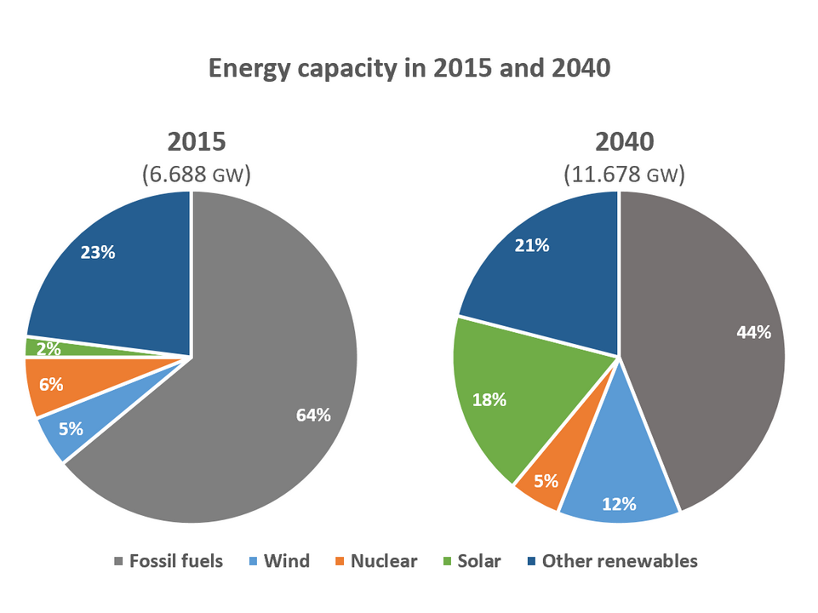
The pie graphs illustrate how energy capacity in gigawatts (GW) distributed in the past 2015 and possible changes in 2040. The use of fossil fuels will largely decrease while the application of wind and solar will increase sharply in 2040.
It is noticeable that the overall energy capacity in 2024 will be nearly twice as that in 2015, rising to 11.678 GW in 2040 from 6.688 GW in 2015. It is crystal clear that fossil fuels consist of the largest proportion of energy capacity in 2015 and will still remain the biggest figure in 2040, however, it will experience a decrease from 64% to 44%.
To the contrary, as the lowest proportion of energy in 2015, solar will become more popular in 2040, with the proportion climbing from 2% to 18%. Similarly, the use of wind energy will experience an increase from 5% in 2015 to 12% in 2040. While the proportion of energy from nuclear and other renewables will decrease slightly from 2015 to 2040.
All in all, some forms of the renewable energy, such as wind and solar, will replace a portion of traditional fossil fuels by 2040, while the latter still remain the most prominent.

